**PIZZA SALES SQL QUERIES**

1. **KPI’s**
2. **Total Revenue**

Select sum (total_price) as Total_Revenue from pizza_sales

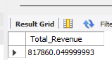

1. **Average Order Values**

Select (sum (total_price)) / (count(distinct(order_id))) as Average_Order_Values from pizza_sales;

N b 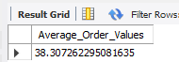

1. **Total Pizzas Sold**

select sum(quantity) as Pizzas_Sold from pizza_sales



1. **Total Orders**

select count(distinct(order_id)) as No_of_order from pizza_sales;

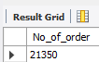

1. **Average Pizzas Sold**

select( sum(quantity) / count(distinct(order_id)) ) as average_pizzas_sold from pizza_sales

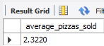

1. **Chart requirements**
2. **Daily trend by its orders**

SELECT dayname(order_date) AS day_name, COUNT(DISTINCT order_id) AS order_count

FROM pizza_sales

GROUP BY day_name

ORDER BY field(day_name,'Sunday','Monday','Tuesday','Wednesday','Thursday','Friday','Saturday');

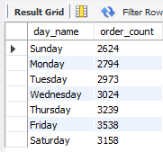

1. **Hourly trends for total orders**

Select hour(order_time) as Hour_, count(distinct(order_id))as Order_count from pizza_sales

Group by Hour_ order by Hour_;

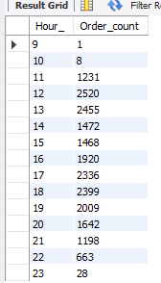

1. **Percentage sales by its category**

select pizza_category, sum(total_price) as total_sales, sum(total_price)*100/(select sum(total_price) from pizza_sales) as Percentage from pizza_sales

group by pizza_category;

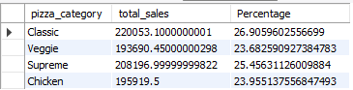

1. **Percentage sales by pizza sizes**

select pizza_size, sum(total_price) as total_sales, sum(total_price)*100/(select sum(total_price) from pizza_sales) as Percentage from pizza_sales

group by pizza_size

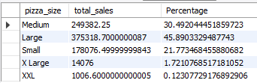

1. **Total pizzas sold by categoty**

select pizza_category, sum(quantity) as quantity from pizza_sales group by pizza_category;

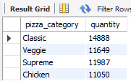

1. **Top 5 Pizzas sold**

select pizza_name, sum(quantity) as Pizzas_sold from pizza_sales group by pizza_name

order by Pizzas_sold desc limit 5

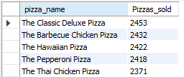

1. Bottom 5 Pizzas sold

select pizza_name, sum(quantity) as Pizzas_sold from pizza_sales group by pizza_name

order by Pizzas_sold asc limit 5

